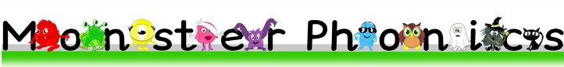

Accessing the e-books

Please find the following information on how to access the e-books.
- Clink on the link below.
https://monsterphonics.com/register/ebooks-whole-scheme/?ca=3a0e45a83aa4844a8d4bf89a688867c7
- Complete the form.
- This will create a specific eBook login.
Now that you have access to the Monster Phonics e-books, you will be able to listen to your child read at home.
Your child’s teacher will write in their diary at the end of the week, to tell you which book they have been reading in school, for example, Stage 5, Book 2 “Hide and Seek”
Once you click on the relevant stage, there is a parent guide which explains how you can support your child with reading at home.
Once you have read this, you can click on the correct stage and find the chosen book.

Your child will have read this book throughout the week. It is important that your child reads this book as independently as possible.
- Before your child reads the book, please go through the words at the front of the book.
- Once your child has read the book, you can ask them the questions to see if they have understood the text.
- Please encourage them to read with some fluency and expression.

IF YOU REQUIRE ANY FURTHER INFORMATION, THERE IS A LINK AT THE BOTTOM OF THE PARENTS’ GUIDE TO A PARENTS’ WEBINAR THAT IS FREE TO ATTEND.

In addition to the e-book, your child will have a banded reading book that you can support them with and, a real book that is to be shared either by you reading with them or to them.

Please continue to write in your child’s diary, to let us know how they are doing with their reading at home.

